Malawi

## Freedom House political status

The data set shows the Freedom House political scores and status of the country each year.

## # A tibble: 19 x 5  
## country iso3c date mean status   
## <chr> <chr> <dbl> <dbl> <chr>   
## 1 Malawi MWI 1996 2.5 Free   
## 2 Malawi MWI 1998 2.5 Free   
## 3 Malawi MWI 2000 3 Partly Free  
## 4 Malawi MWI 2002 4 Partly Free  
## 5 Malawi MWI 2003 3.5 Partly Free  
## 6 Malawi MWI 2004 4 Partly Free  
## 7 Malawi MWI 2005 4 Partly Free  
## 8 Malawi MWI 2006 3.5 Partly Free  
## 9 Malawi MWI 2007 4 Partly Free  
## 10 Malawi MWI 2008 4 Partly Free  
## 11 Malawi MWI 2009 3.5 Partly Free  
## 12 Malawi MWI 2010 3.5 Partly Free  
## 13 Malawi MWI 2011 3.5 Partly Free  
## 14 Malawi MWI 2012 3.5 Partly Free  
## 15 Malawi MWI 2013 3.5 Partly Free  
## 16 Malawi MWI 2014 3.5 Partly Free  
## 17 Malawi MWI 2015 3 Partly Free  
## 18 Malawi MWI 2016 3 Partly Free  
## 19 Malawi MWI 2017 3 Partly Free

## Freedom House classification of political change

The data set shows the GDP growth and the ecomic growth classification of the country each year.

## # A tibble: 19 x 4  
## country iso3c date politicalChangeFH  
## <chr> <chr> <dbl> <chr>   
## 1 Malawi MWI 1996 no change   
## 2 Malawi MWI 1998 no change   
## 3 Malawi MWI 2000 no change   
## 4 Malawi MWI 2002 autocratization   
## 5 Malawi MWI 2003 democratization   
## 6 Malawi MWI 2004 autocratization   
## 7 Malawi MWI 2005 no change   
## 8 Malawi MWI 2006 democratization   
## 9 Malawi MWI 2007 autocratization   
## 10 Malawi MWI 2008 no change   
## 11 Malawi MWI 2009 democratization   
## 12 Malawi MWI 2010 no change   
## 13 Malawi MWI 2011 no change   
## 14 Malawi MWI 2012 no change   
## 15 Malawi MWI 2013 no change   
## 16 Malawi MWI 2014 no change   
## 17 Malawi MWI 2015 democratization   
## 18 Malawi MWI 2016 no change   
## 19 Malawi MWI 2017 no change

## Freedom House score trend

The plot shows the Freedom House scores trend of the country.

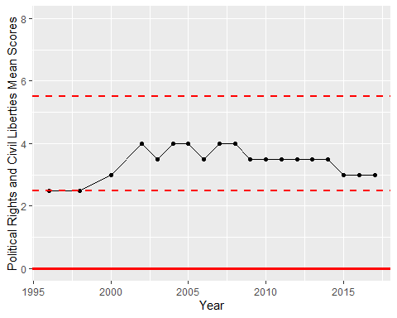

Freedom House Score Trend